ATAR CHEMISTRY – UNIT 3
TASK 3 – Titrations Lab Validation
TOTAL MARKS:
/22

NAME: MARKING KEY
Clearly write your answer in the space provided. Where applicable show all working out and round final calculations to appropriate significant figures.

- Other than having a relatively low molar mass, give two reasons why hydrochloric acid is not a good primary standard.
Any two relevant points. Answers could include:
- Pure HCl is a gas at room temperature
- Highly reactive
- Concentration/purity of the sample is uncertain

(2 marks)

- Write a balanced chemical equation for the reaction between hydrochloric acid and sodium carbonate.

2 HCl + Na₂CO₃ à 2 NaCl + H₂O + CO₂

1 mark correct species, 1 mark correctly balanced(2 marks)

- From your results, calculate the average titre value.

Average calculated using values within 0.3mL of each other.
(1 mark)

- Use your titration results and additional information from the whiteboard to calculate the percentage by mass of Na₂CO₃ in the Na₂CO₃/NaCl mixture.

n(HCl) = cV = c x titre value
n(Na₂CO₃) = ½ n(HCl) =

m(Na₂CO₃) = nM = n x 105.99

m(mixture) = d x 20 =

mass% of Na₂CO₃ = m(Na₂CO₃) / m(mixture) x 100 =

(5 marks)
- Assessment of accuracy: YOUR TEACHER WILL FILL THIS PART OUT.

± 0-5% ± 5.1-10% ± more than 10% (2 marks)
- A household cleaner claims to be 3% ammonia by mass, in order to determine if this claim is accurate the following process was performed.

- A 100.0mL sample of the cleaner was diluted and made up to a volume of 2.00L.
- 20.0mL samples of this diluted solution were then titrated against a standardised 1.00 x 10⁻¹ mol L⁻¹ HCl solution.
- A 20.00 mL sample of the cleaner was found to have a mass of 18.20g

- Complete the following table by writing the name of the most suitable piece of equipment to use for each task, and what that equipment should be rinsed with before use.

Task | Equipment Used | Final Rinse With
Adding the hydrochloric acid solution to the diluted cleaner. | Burette | HCl solution
Diluting the 100.0mL sample of cleaner up to exactly 2.0L. | Volumetric flask | Distilled water
Measuring 20.0 mL aliquots of the cleaner solution. | Pipette | Diluted cleaner solution
(6 marks)
- Name a suitable indicator that could be used for this titration and explain why.

Methyl red/Methyl orange (or any suitable with acidic end-point)

Has an acidic end-point, which is similar pH to the equivalence point of this titration.
(2 marks)

- The colour change for the indicator Thymolphthalein is shown below.
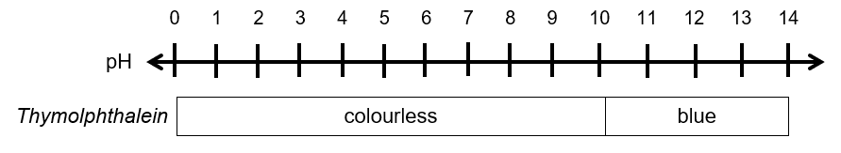

State and explain how the calculated concentration of ammonia in the cleaner would be affected if the indicator Thymolphthalein were used for this titration.

Concentration would be lower.

End-point will occur before equivalence point. (or any suitable explanation)

(2 marks)

